AppStream Security Concerns
Below are the Concerns which “Dexter” Raised.
  - Strong authentication – integration with Azure AD SSO or availability of MFA
  - Anti-Malware protection – configured with real time protection and performs full disk scanning.
  - Endpoint integrity – prohibit users from installing or executing unauthorized software, applications, etc.
  - Data protection:
    - Block access to local drive, usb storage
    - Compatibility with existing DLP capabilities, i.e., McAfee, MS DLP; allowing monitoring of unauthorized movements of confidential data.
  - Web filtering
    - Immediate Priority, block access to public mail and cloud storage (e.g., google drive, iCloud, etc.)
    - For subsequent enhancement, block other non-business website categories (like our Windows endpoints)
  - Restrict admin privileges.
  - For enhancements (let’s have a plan to have this in place):
    - Endpoint incident response – ability for us to contain/isolate/terminate endpoint and gather logs (for forensics)
    - Restrict access from UNO managed endpoints and registered/nominated devices (like conditional access in our Windows endpoints)

Checklist of Security Endpoints

Below is the resolution we identified.

- Strong authentication: - We already implemented the SSO Integration with Azure AD. It will resolve the issue, If Dexter, ask us to enable the MFA Authentication we can also do that with the help of Vergel.
- Anti-Malware protection: - We have the inbuilt functionality in our Windows Server named Windows Defender Antivirus Service, we already enabled it in the admin side and will incorporate those changes in User end as well. Below is the Screenshot for the reference.
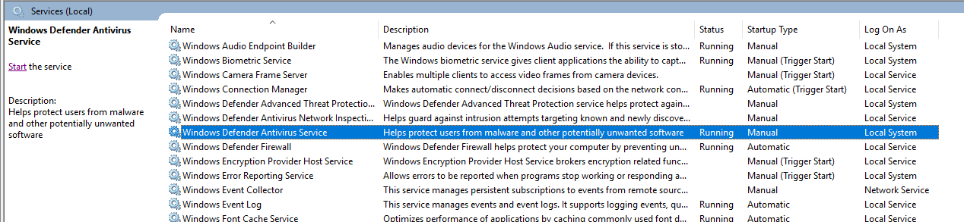

- Endpoint integrity: - This Security Endpoints we already incorporated in the AppStream, below is the example of User side. What error he faces if he installs unwanted software.

- We downloaded the Brave Browser from Chrome now we will try to run that executable file on user side.
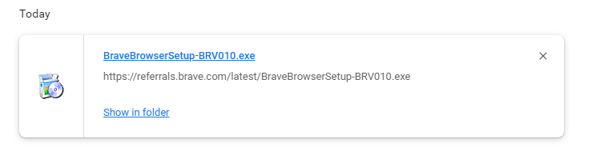

- Below is the error if we double click on that software.

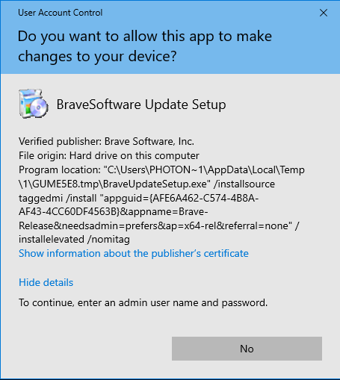

- Suppose if a user wants to delete the software. They cannot perform that task, below is the error.

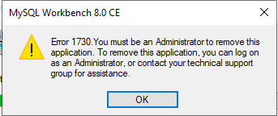

- Data protection:
    - Block access to local drive, usb storage: -
    - Compatibility with existing DLP capabilities, i.e., McAfee, MS DLP; allowing monitoring of unauthorized movements of confidential data.

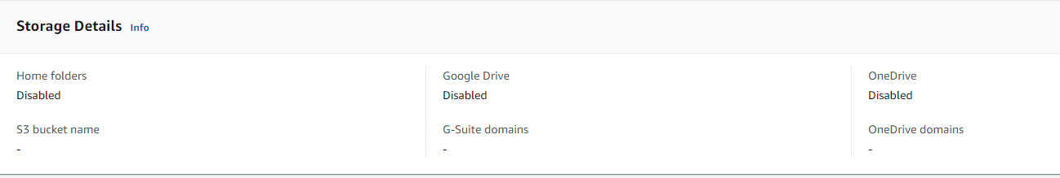
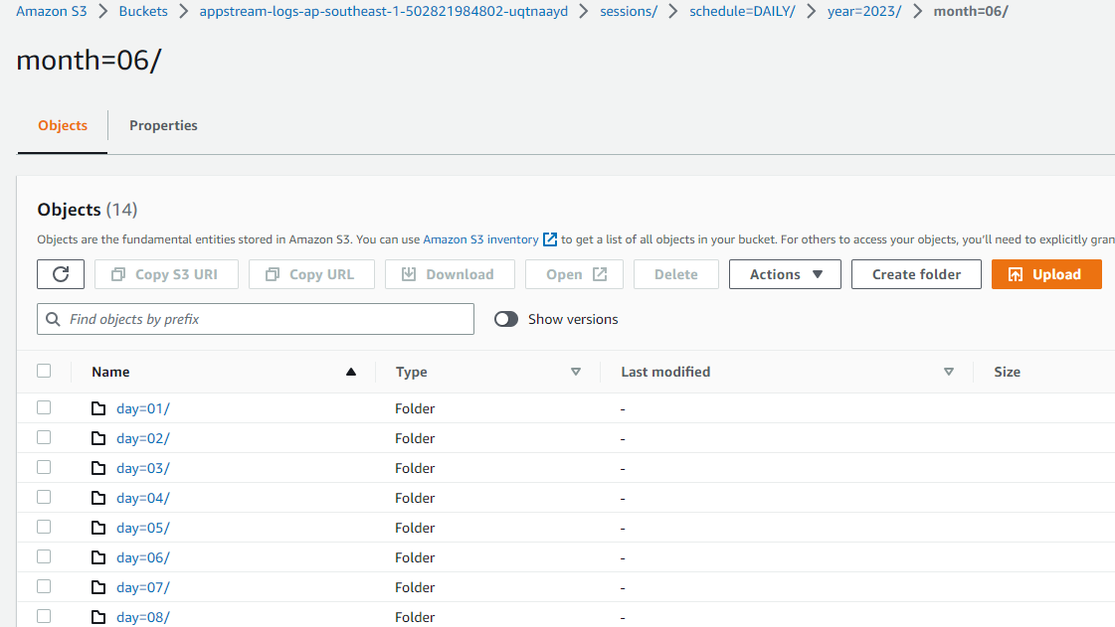

- Web filtering
    - Immediate Priority, block access to public mail and cloud storage (e.g., google drive, iCloud, etc.)
    - For subsequent enhancement, block other non-business website categories (like our Windows endpoints)

Blocked URL’s in AppStream

- drive.google.com
- www.facebook.com
- www.web.whatsapp.com
- web.whatsapp.com
- www.whatsapp.com
- www.icloud.com
- Gmail
- Yahoo

- From AppStream itself we have disabled Google Cloud, OneDrive & AWS S3 Bucket.

- We have already blocked some of the website like Gmail, Google Drive, facebook.com.
- We can do it for more website, just wanted to create a list of URLS which needs to be Blacklisted.

- Restrict admin privileges: -
- As I already showed it to you, User don’t have any permission to do any of the unauthorised thing.
- No installation of software without admin privilege.

- Zoom Installer:- Insufficient Space to install.
- Amazon Workspace:- Insufficient to install.
- Acrobat Reader:- Need Administrator permission
- VS code:- Insufficient Space to install.
- Teams:- Need Administrator permission
- Brave:- Need Administrator permission
- Win Merge:- Need Administrator permission.

- Zoom Error.
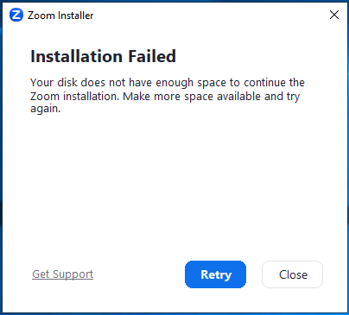

- Workspace Error

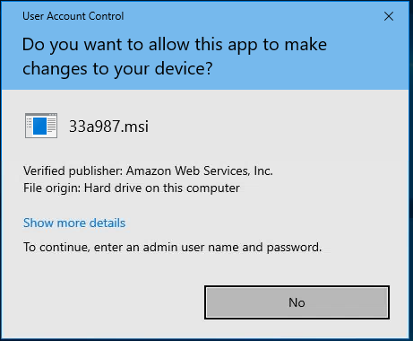

- Adobe Acrobat Reader
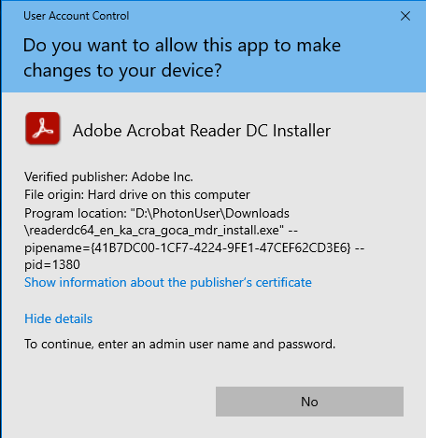

- VS Code.
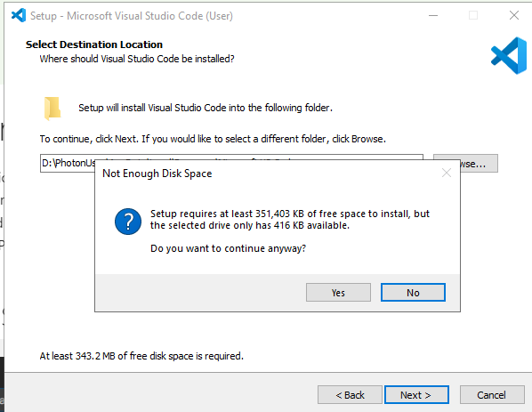

- Teams
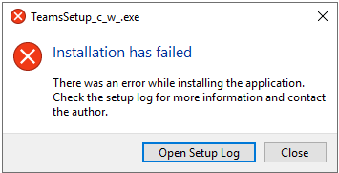

- Brave Browser
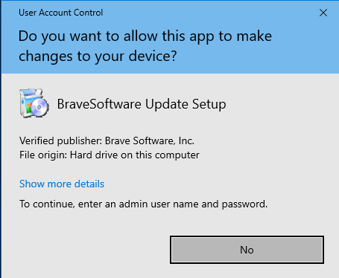

- Win Merge
